Ai Marketing Landing Page

I need a landing Like this Simple: https://www.acquisition.com/o-vegas
Here Section: Animated at the beginning in to Hero section like Acq with
H1: “SCALE YOUR REVENUE BY 300% WITH Ai AD”
H2: We reverse-engineer the highest-converting ads frameworks to build your ads that get clints.
Then video Section and under that CTA: I'm Ready to Scale
Clour and system for this landing page: https://colorkit.co/color-palette-generator/222222-0392C5-073E79/
Our logo need only in footer 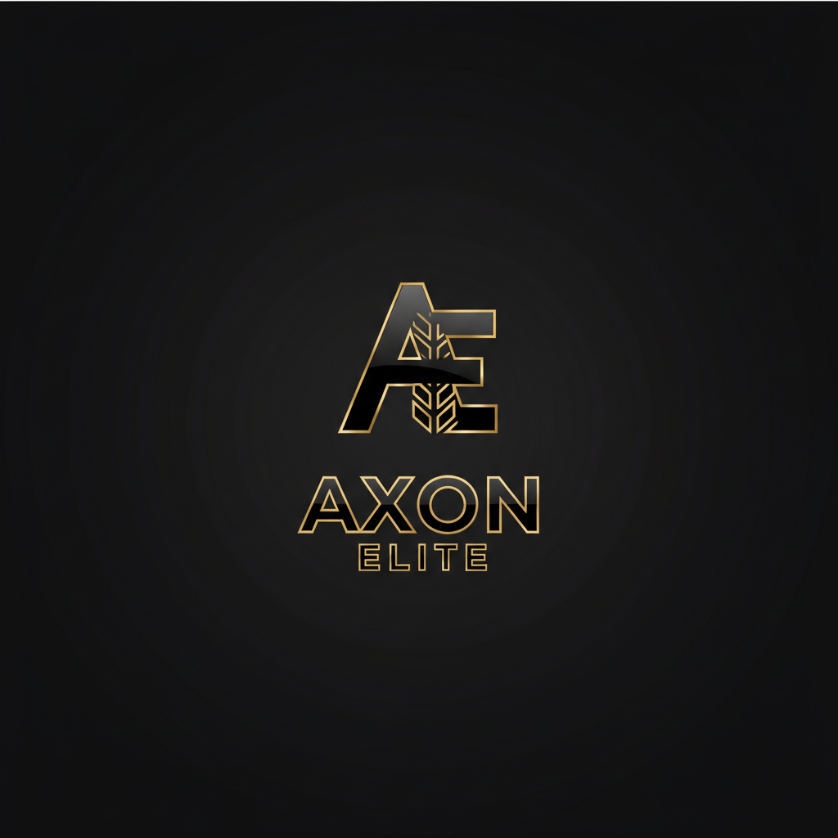
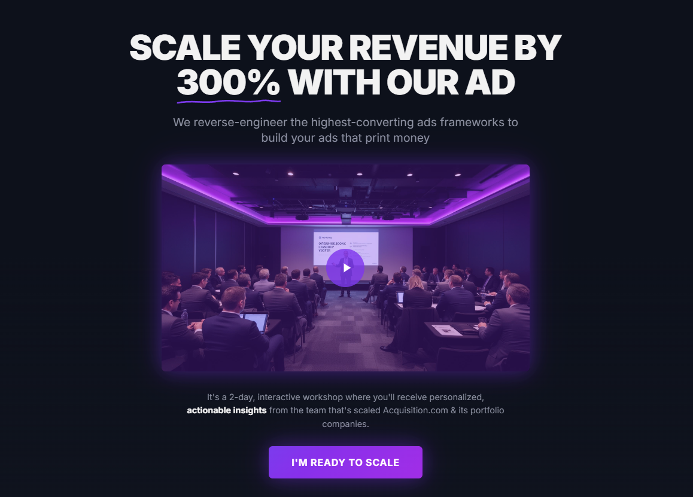
Second Section: Use this website Check out our work, where i want to upload different vid for the section. I will give the video later.
https://fraggellproductions.com/#scroll-work
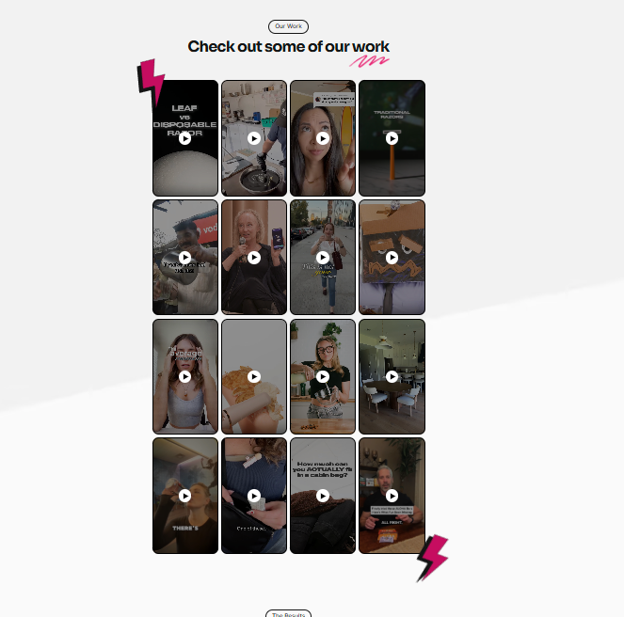
Section 3: Come up with a Head line
Section #1:
Head line : Elite Directors
You'll meet with our elite directors for a personalized strategy session. We'll map out the exact ad systems and frameworks to scale your business with AI-powered creatives.
#2
Elite Scaling Framework: We'll break down how we think, operate, and scale — showing you how to think like an elite marketer so we can push your business to 300%+ growth.
#3: come up with a head line
Massage: We'll understand about
We’ll deep-dive into your specific niche to identify exactly what’s winning in your market right now. Then, we’ll build a custom AI workflow designed to generate viral, high-converting creatives on demand. You’ll leave with a localized Go-To-Market plan and the system to execute it.
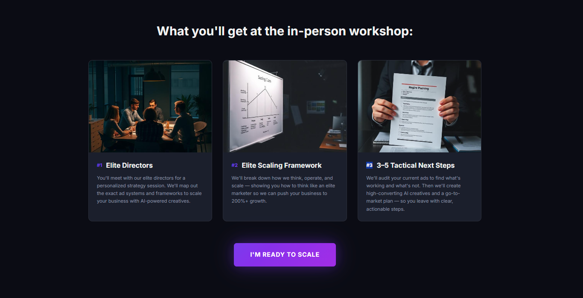

Section four: What our Clint says
Find Top Marketers review and put them as it is ours.
Section 5: Embedded link for calendly
Headline : Book Your Call
Find a good subheadline that work well.
Section 6: Frequently Asked Questions
Q1 : What exactly is the "Elite Scaling Framework"? A: It’s our proprietary 3-step system:
- Intelligence: Analyzing your niche's top-performing data.
- Creation: Generating high-converting AI assets.
- Execution: Deploying a Go-To-Market plan that optimizes for the lowest CPA (Cost Per Acquisition) and highest scale.
Q2: Doesn’t AI marketing look "fake" and robotic?
Most of it does—and that’s why most AI ads fail. Cheap AI looks "uncanny," hurts brand trust, and results in bottom-tier conversion rates. Our system is different. We produce high-fidelity, professional-grade content that is indistinguishable from high-budget human production. Because our AI is trained on actual viral data and real human aesthetics, your brand stays premium while your creative output becomes limitless.
Q3: What we do
We are your full-scale Growth & Brand Partner. We don’t just give you a login; we take over the heavy lifting. This includes:
- Social Media Management: We handle your organic presence and brand voice.
- Ad Creative & Strategy: We design, test, and optimize every single ad.
- Market Dominance: We act as your outsourced CMO office, managing your brand's digital footprint so you can focus entirely on your operations.
Q4: Why choose this over a traditional agency
Traditional agencies are slow, expensive, and rely on "creative intuition" (guessing). We rely on data and speed.
Our system identifies exactly what is already winning in your market and replicates those triggers for your brand at a fraction of the cost of a traditional agency. You get elite-grade content, better conversion data, and the speed to scale that a manual human team simply cannot match.

